

Software Quality

Assignment 2

# Connect 4 - Game Development

Allan Santosh – 100557518

# Introduction

The game I chose to do for this assignment is Connect 4. This is a two-player game where the objective of the game is to be the first person to connect four of the same pieces horizontally, vertically or diagonally. The game starts by inputting player names first and then player one gets to drop the first piece in the grid followed by the second player. Each player plays turn by turn until one of them can get four of the same pieces together and then the game terminates and declares the winner.

#### Sample Output

-------------------------

| Connect 4 |

-------------------------

| | | | | | |

| | | | | | |

| | | | | | |

| | | | | | |

| | | | | | |

| | | | | | |

-------------------------

| 1 2 3 4 5 6 |

-------------------------

Welcome to Connect 4. Hope you enjoy the game.

Enter player 1 name : Batman

Enter player 2 name : Superman

Batman, your symbol is 'O'. Enter column you want to mark : 1

-------------------------

| Connect 4 |

-------------------------

| | | | | | |

| | | | | | |

| | | | | | |

| | | | | | |

| | | | | | |

| O | | | | | |

-------------------------

| 1 2 3 4 5 6 |

-------------------------

Superman, your symbol is 'X'. Enter column you want to mark : 3

-------------------------

| Connect 4 |

-------------------------

| | | | | | |

| | | | | | |

| | | | | | |

| | | | | | |

| | | | | | |

| O | | X | | | |

-------------------------

| 1 2 3 4 5 6 |

-------------------------

Batman, your symbol is 'O'. Enter column you want to mark : 1

-------------------------

| Connect 4 |

-------------------------

| | | | | | |

| | | | | | |

| | | | | | |

| | | | | | |

| O | | | | | |

| O | | X | | | |

-------------------------

| 1 2 3 4 5 6 |

-------------------------

Superman, your symbol is 'X'. Enter column you want to mark : 4

-------------------------

| Connect 4 |

-------------------------

| | | | | | |

| | | | | | |

| | | | | | |

| | | | | | |

| O | | | | | |

| O | | X | X | | |

-------------------------

| 1 2 3 4 5 6 |

-------------------------

Batman, your symbol is 'O'. Enter column you want to mark : 1

-------------------------

| Connect 4 |

-------------------------

| | | | | | |

| | | | | | |

| | | | | | |

| O | | | | | |

| O | | | | | |

| O | | X | X | | |

-------------------------

| 1 2 3 4 5 6 |

-------------------------

Superman, your symbol is 'X'. Enter column you want to mark : 3

-------------------------

| Connect 4 |

-------------------------

| | | | | | |

| | | | | | |

| | | | | | |

| O | | | | | |

| O | | X | | | |

| O | | X | X | | |

-------------------------

| 1 2 3 4 5 6 |

-------------------------

Batman, your symbol is 'O'. Enter column you want to mark : 1

-------------------------

| Connect 4 |

-------------------------

| | | | | | |

| | | | | | |

| O | | | | | |

| O | | | | | |

| O | | X | | | |

| O | | X | X | | |

-------------------------

| 1 2 3 4 5 6 |

-------------------------

Batman has won the game !!!!

# Software Development Process

For this game, I decided to follow the agile development. This project was completed successfully in the time given. The reason I chose to follow the agile process is because during the coding phase my requirements changed. I was able to adapt the new changes and make It reflect on the code instantly. Due to the drawbacks of waterfall and incremental which doesn’t allow me to do revisions on my work; and also, since the time frame given for this assignment was long, it doesn’t fit the waterfall model and I decided to choose the agile development process.

Agile development is the best as it always allows for room for change. Especially games are always better with minor changes added to it, agile development is the way to go.

# Functionality

The simple command line interface game of connect 4 doesn’t need additional libraries to be loaded. All the source files that are compiled can be found under the ‘bin’ folder. Since the program is written in Java, Java needs to be installed on the system. The testing is all done with Junit which was installed onto the Eclipse IDE.

# Challenges

One of the challenges I had with testing is the code itself. I didn’t make object of different game instances. Instead I only made one static game board which didn’t allow me to see what happened when I run methods that were meant for objects.

Finding test cases that had most coverage was hard. Considering if this project were to be expanded to a bigger grid, then a different test method needs to be implemented.

# How to Install

Step 1: Install Eclipse IDE from <https://www.eclipse.org/downloads/>

Step 2: Make a new folder in desktop and clone the GitHub repo using the command

git clone <https://github.com/allansantosh/Connect-4>

Step 3: Open Eclipse IDE. Press Help and open up Eclipse Market Place.

Step 4: Install Junit from Eclipse Market Place

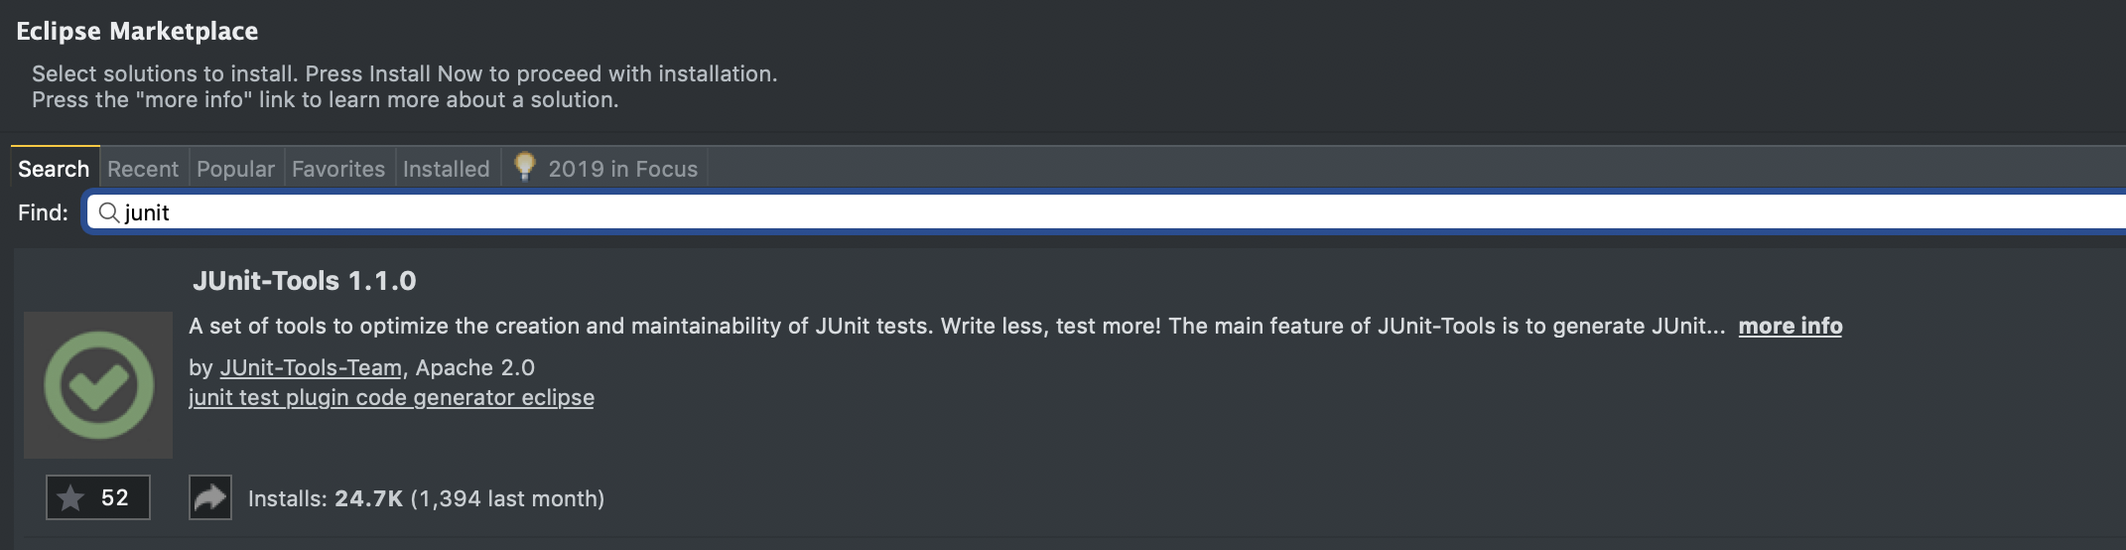

Step 5: Open File 🡪 New Project 🡪 point to the new folder in the desktop where you cloned the GitHub Repo.

Step 6: The project should open as follows.

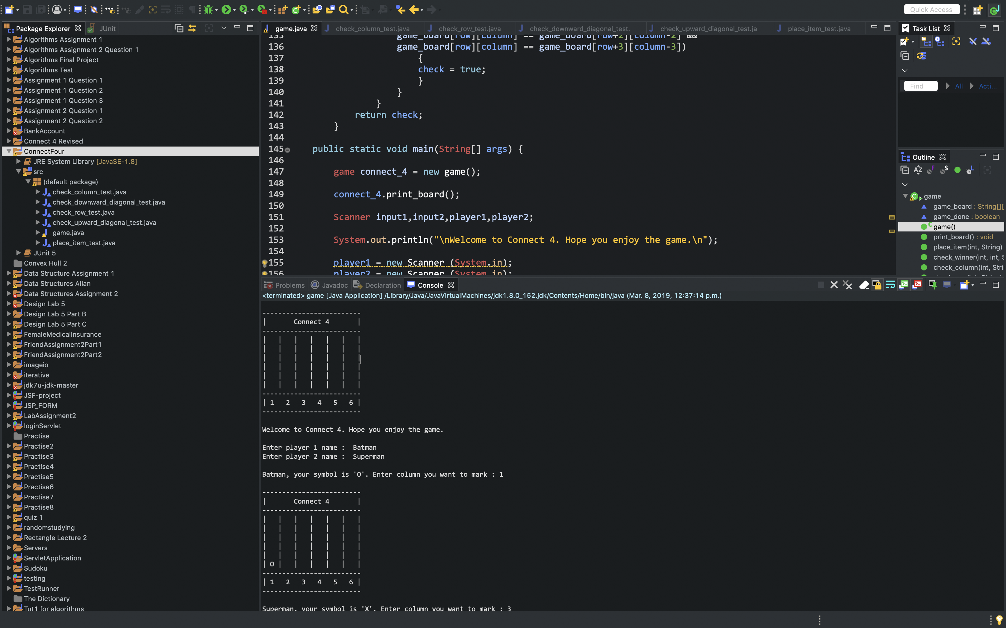

Step 7: Press the green run button to compile and run the game and play the game.

Step 8: In the project explorer, the test cases are also available. Double click on the test case java files and press the green button to run the test cases.

# Running test cases

Note the left side of the images shows if the tests passed or failed.

1. Checking columns if there is 4 of a kind.

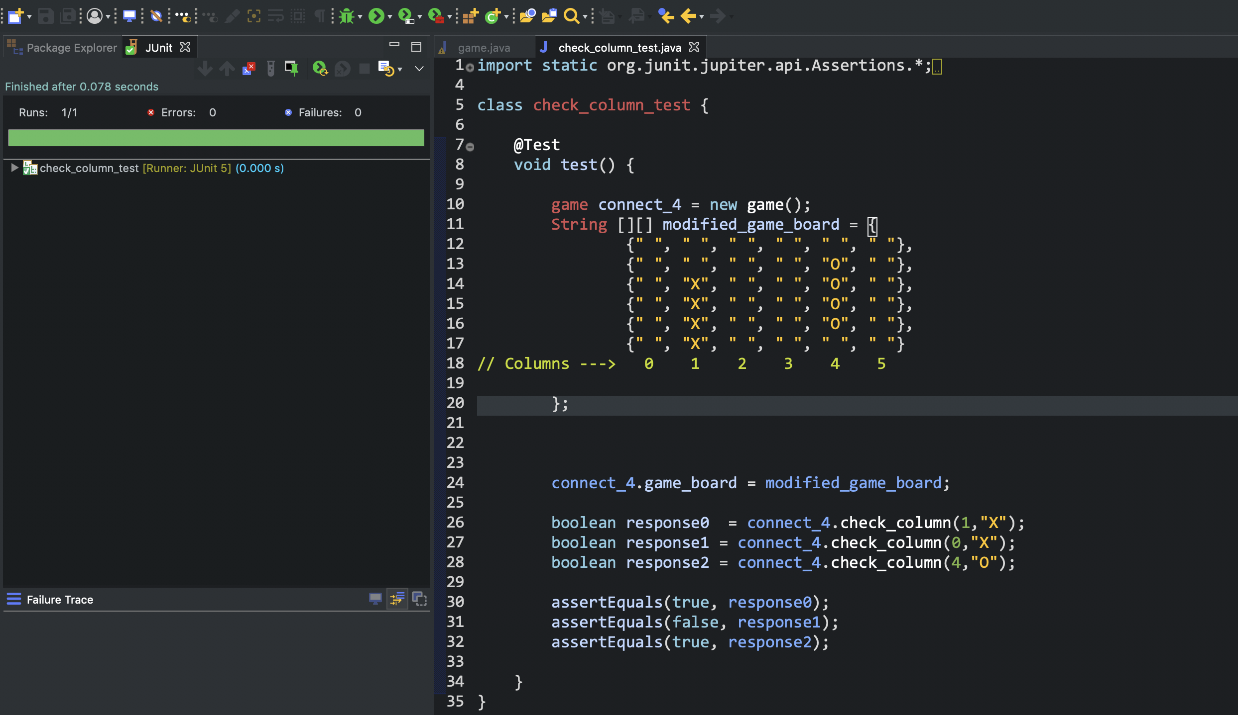

1. Checking if the rows had 4 of a kind.

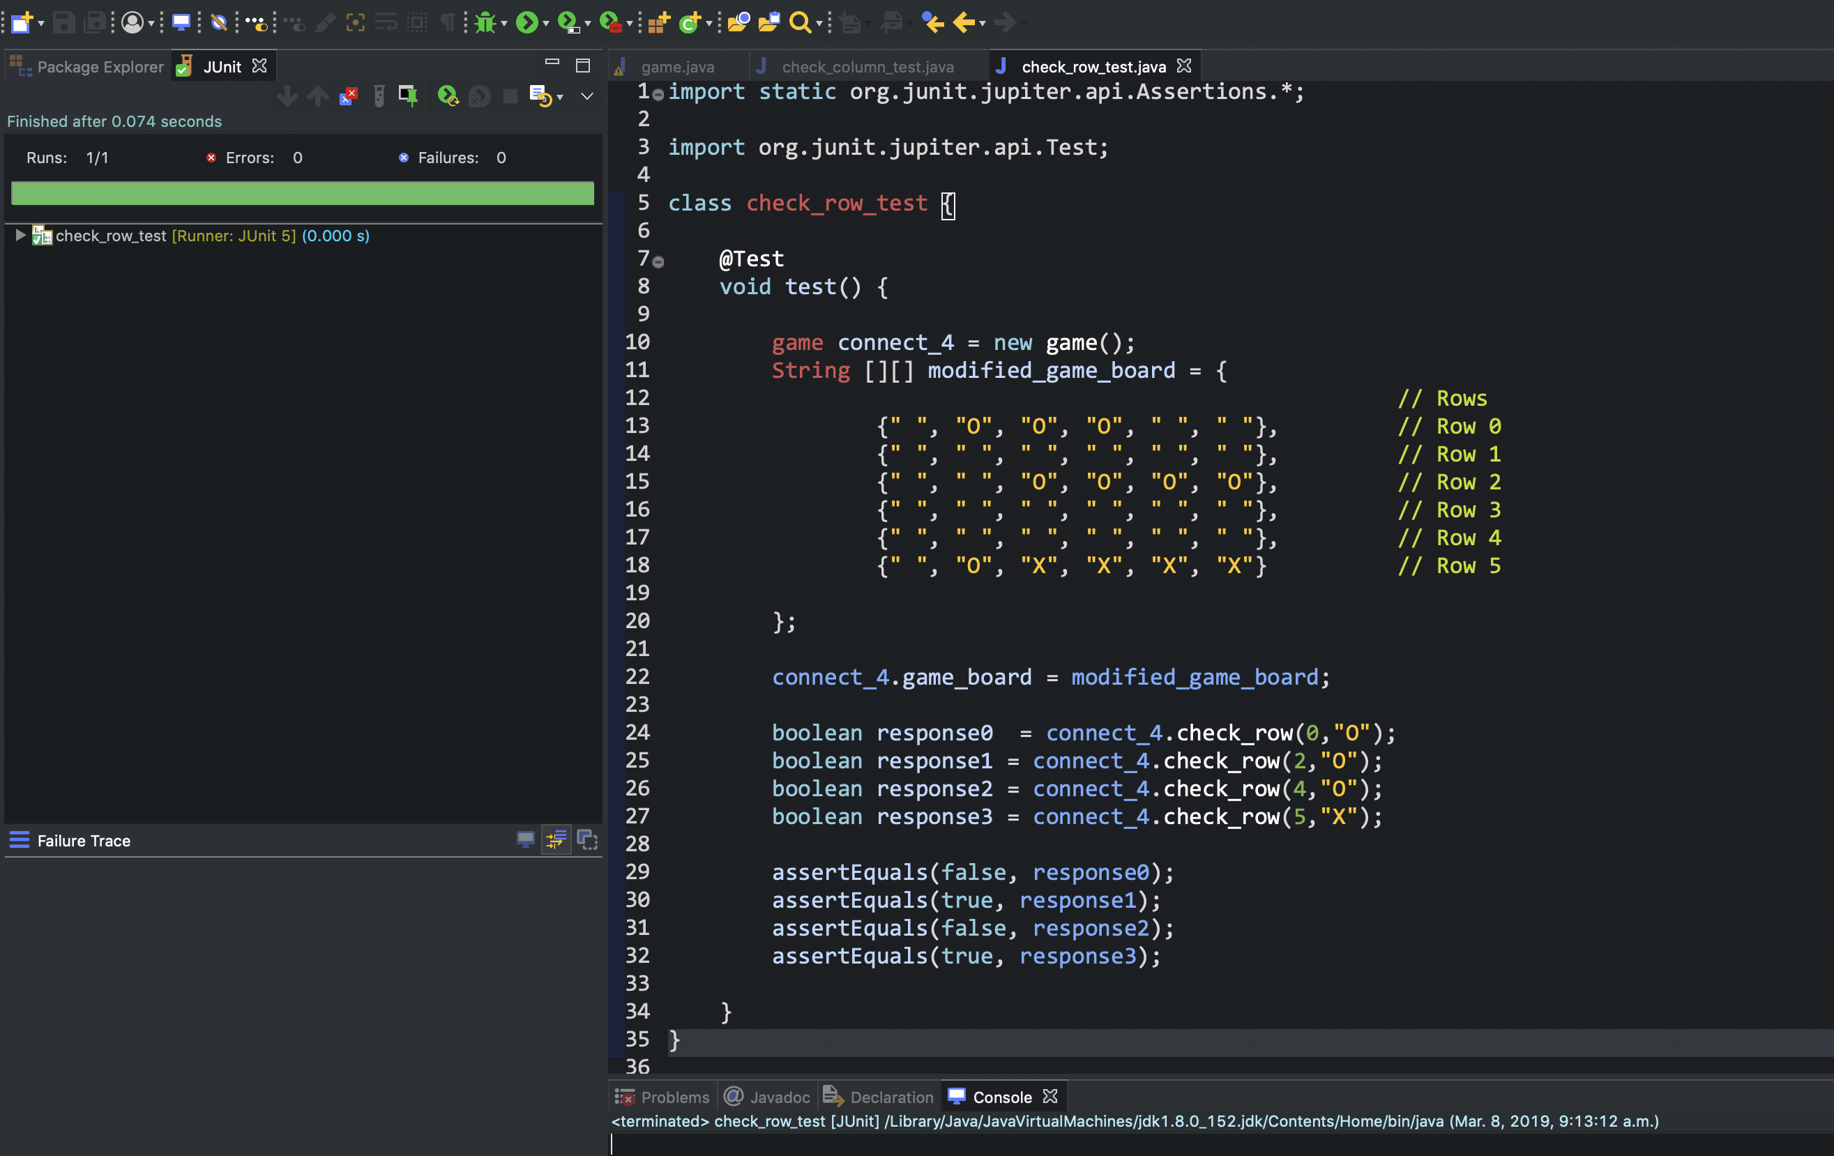

1. Checking the downward diagonal had 4 of a kind.

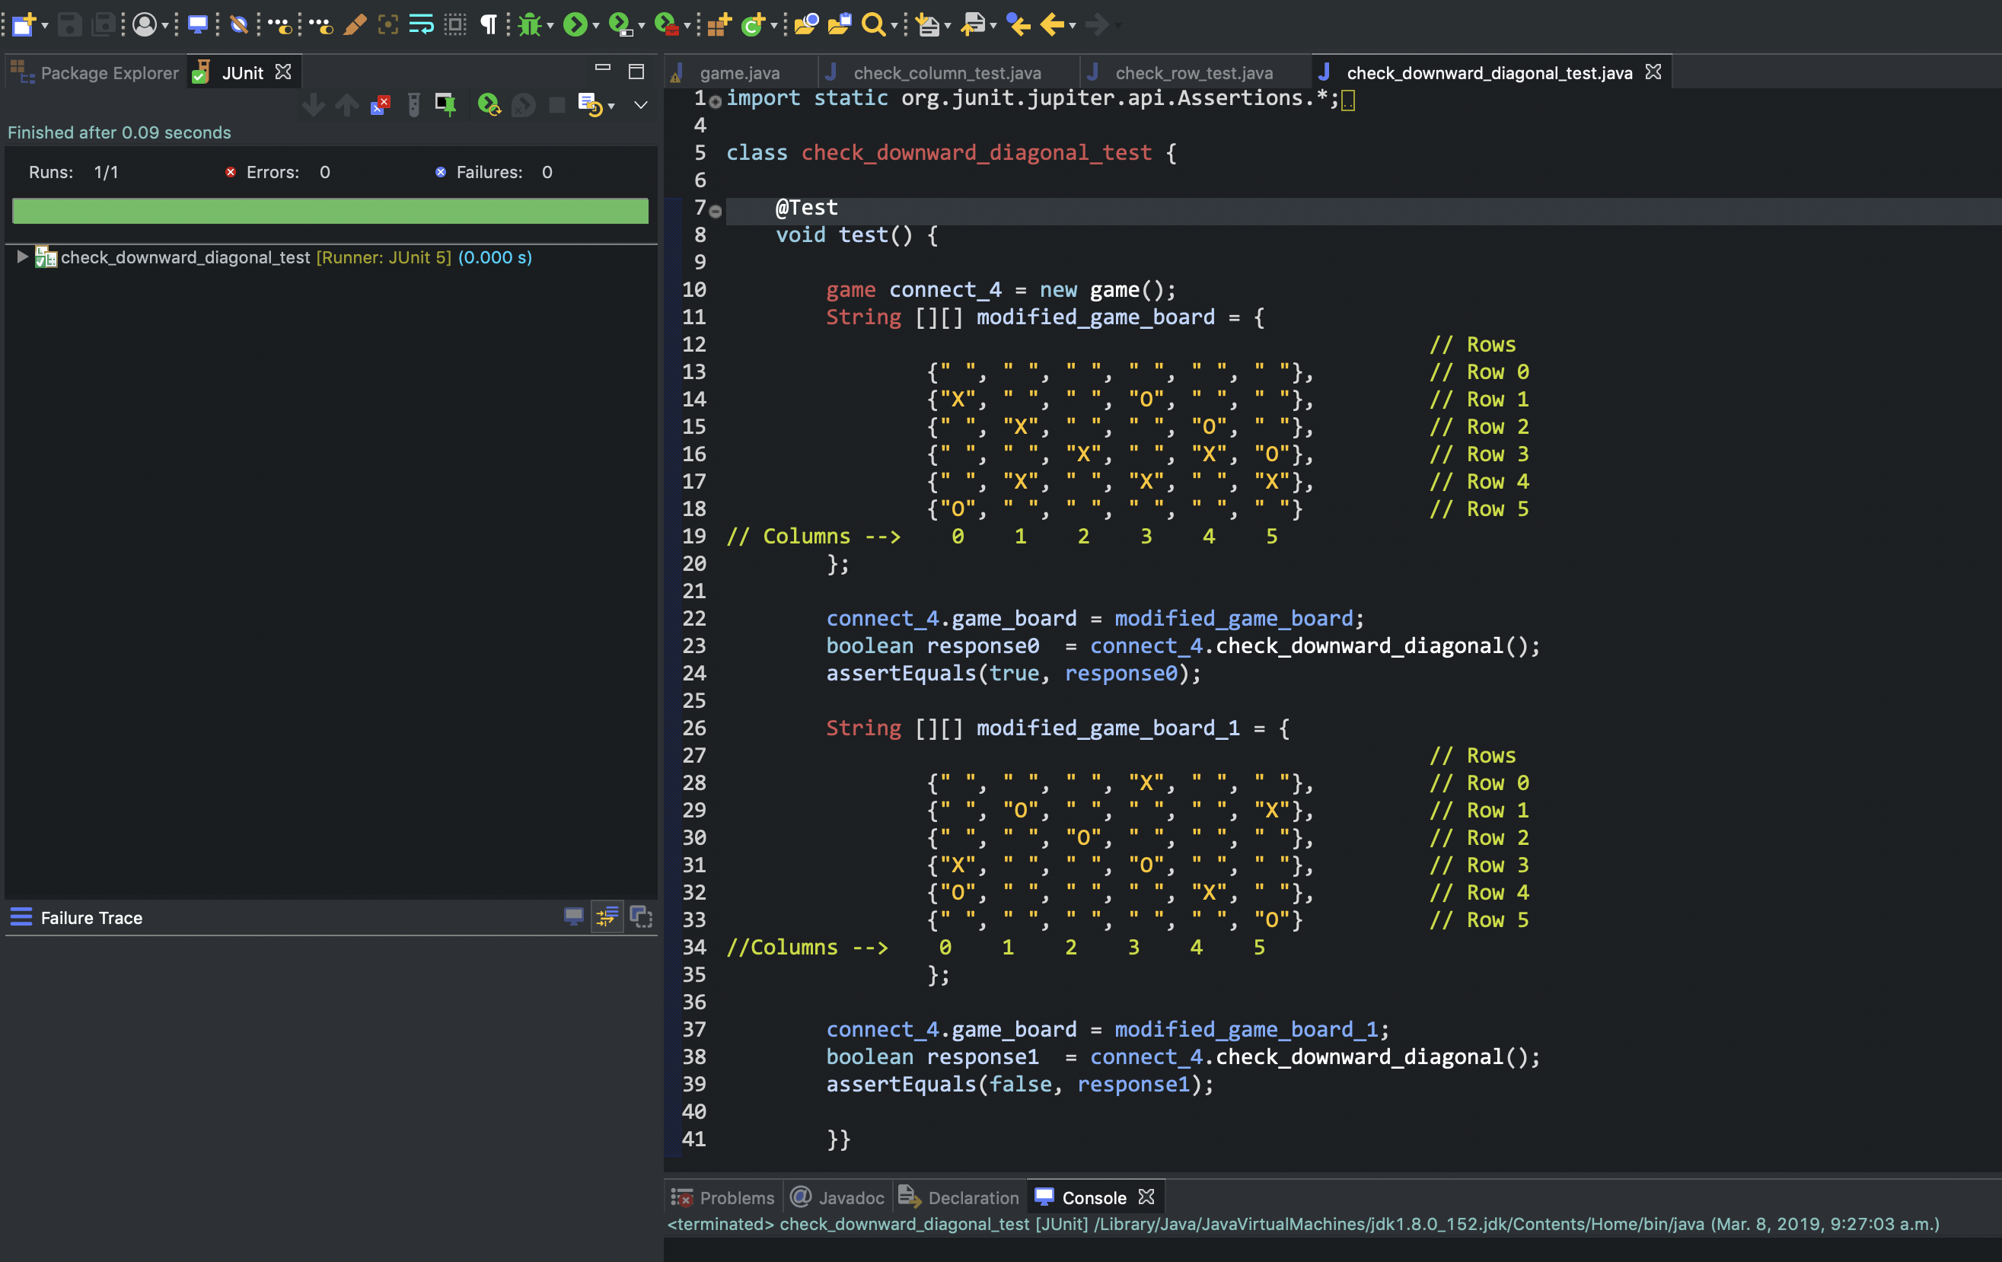

1. Checking if the upward diagonal had 4 of a kind.

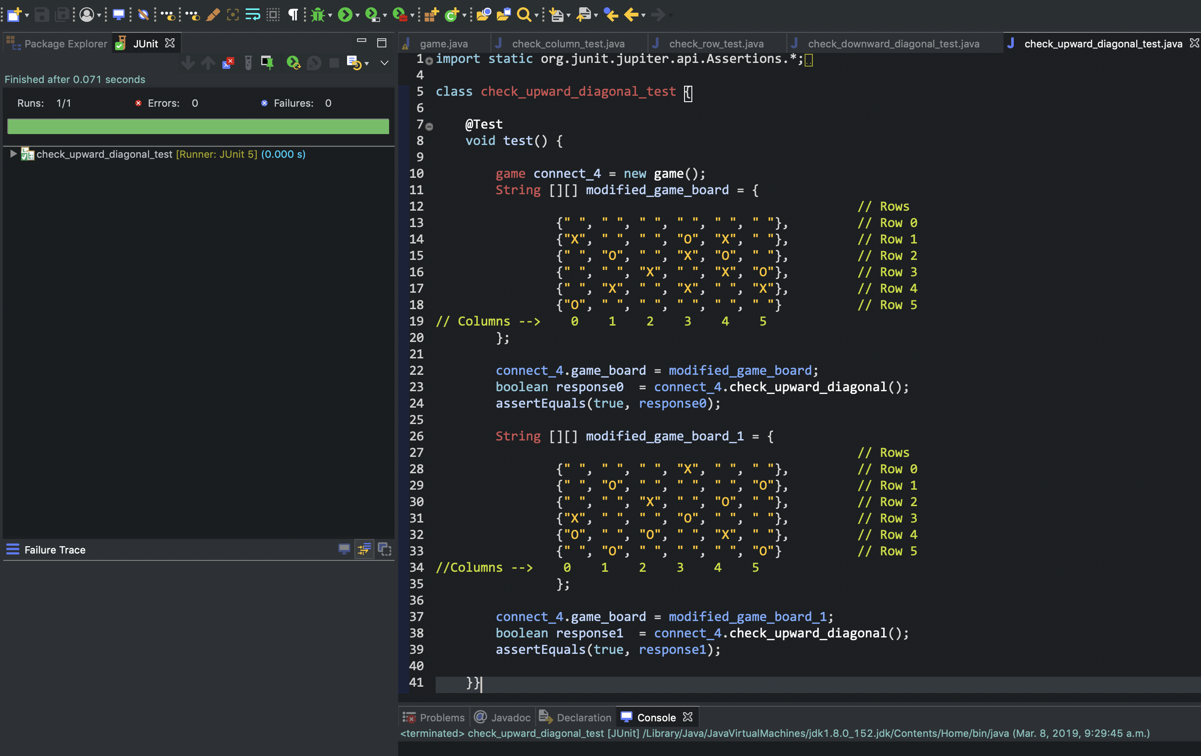

1. Checking if the player places a piece in the grid, does it get placed.

